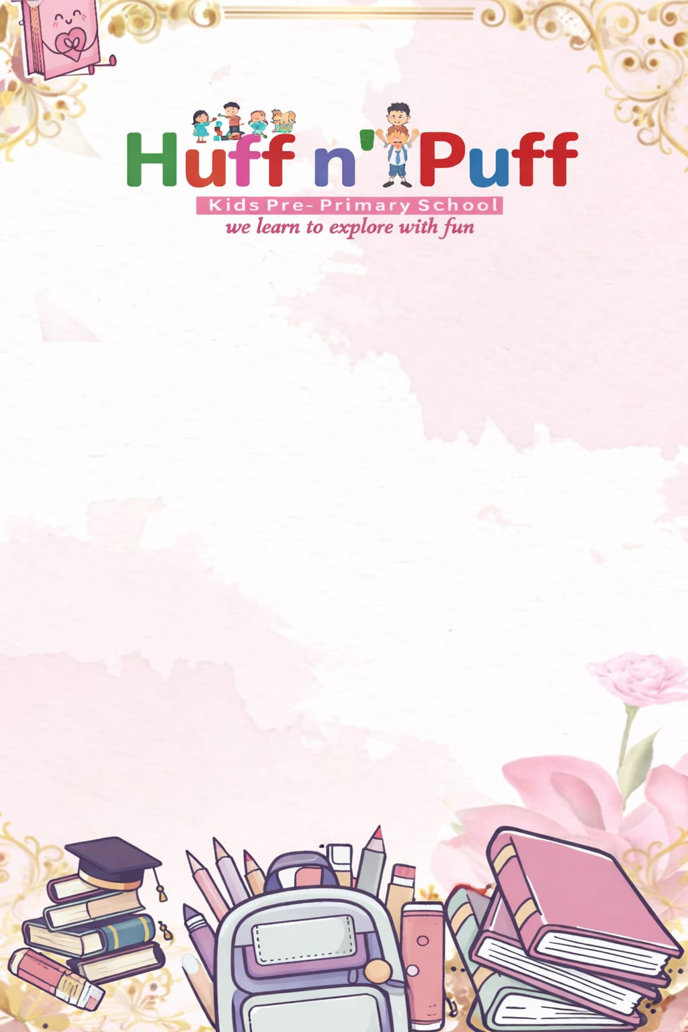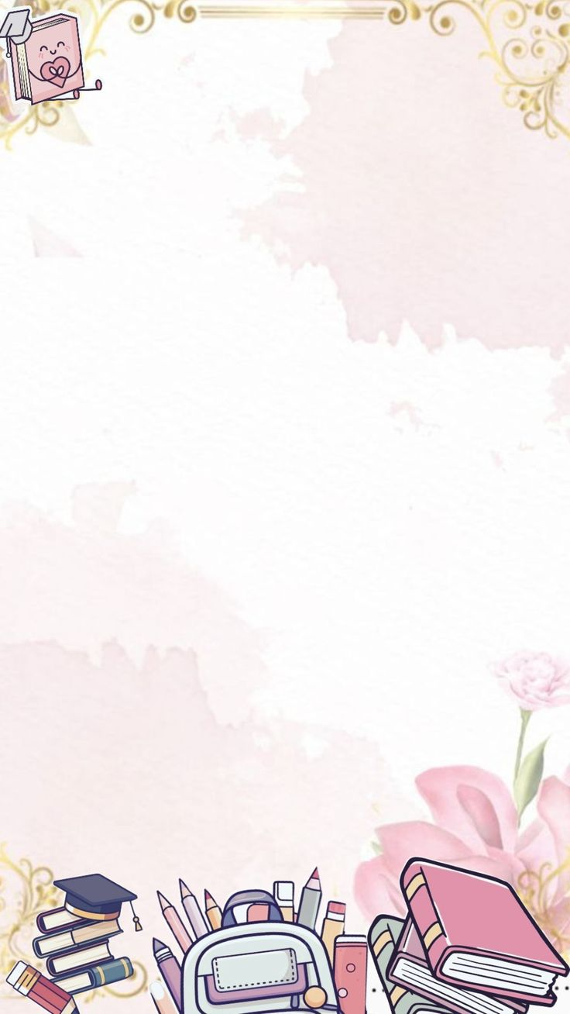
PLAY GROUP SYLLABUS (SESSION–2026–27 )
April
English(Written)–Standing lines and Sleeping lines.
English (Oral) – A to G (Capital letters)
. English(Poem)–Twinkle, Twinkle & Early to bed.
Math’s (Written)–SlantinglinesandTracenumber1.
Math’s (Oral) – Counting 1 to 10.
Hindi(Written)– वक्र रेखा, तिरची रेखा.
Hindi(Oral) –स्वर अ सेईI
Hindi(Poem)– प्रार्थना, मछली
G.K –What is your name , I am .
E.V.S –Fruits name.

May
English(Written)–JointheCurvelines,StandinglinesandSleepinglines.
English (Oral) – A to M (Capital letters).
English(Poem)– Rain-Rain, Go away, cobbler-cobbler.
Math’s(Written)–Circle formation and Trace numbers 1and2.
Math’s (Oral) – Counting 1 to 10.
Hindi(Written)– घुमावदार रेखा.
Hindi(Oral) – स्वर अ सेऋ तकI
Hindi(Poem)– होली, मोतुराम
G.K–I live in my class teacher name.
E.V.S–Parts of Body

June
Summer Vacations
July
English (Written)–Matching Alphabets.
English (Oral) – A to Q (Capital letters).
English (Poem) – हम्प्टी डम्प्टी.
Math’s (Written)–Matching numbers, Matching objects.
Math’s (Oral) – Counting 1 to 15.
Hindi (Written)– चित्रा को देखकर अक्षर मिलाये
Hindi (Oral)–स्वरअसेऐतकI
Hindi (Poem)– आलू कचालू
G.K–I study in huff `n’ puff kids pre –primary school,
How are you.
E.V.S–Vegetables name.

August

English (Written)–(1) Look at the picture and match the alphabet. (2) Trace letter A and B.
English (Oral) – A to U (Capital letters).
English (Poem)–JAck and jill, I see the moon.
Math’s (Written)–Trace over the slanting lines.
Math’s (Oral) – Counting 1 to 20.
Hindi (Written)–चित्र को देखकर चित्र सेमिलाए, अ अ| लिखने का अभ्यास करे I
Hindi (Oral)–स्वर अ से अःतकI
Hindi (Poem)– छाता, आम
G.K–Name of the weak.
E.V.S–Birds name.
September
"It's Exam Time"

October
English(Written)–(1)Circle the letter A. (2)Trace letter A, B and C.
English (Oral) – A to Z (Capital letters).
English (Poem) – johnny, johnny! and Ring-a-ring o'roses.
Math’s (Written)–Circle the number 2 and Trace number1and2.
Math’s (Oral) – Counting 1 to 20.
Hindi (Written)– उ या ई लिखने का अभ्यास करेंI
Hindi(Oral)–स्वर अ से अः तक और क से ड तकI
Hindi (Poem) – पतंग और मम्मी पापा

G.K–National flower ,National animal and national fruits.
E.V.S–Animals name.

November

English(Written)–(1)Matching pictures. (2)Trace letter A,B,C and D.
English (Oral) – A to Z (Capital letters).
English (Poem)–Mummy And Daddy, Thankyou god.
Math’s (Written)–Count the objects and match the number, trace the number 4.
Math’s (Oral) – Counting 1 to 20.
Hindi (Written)– उ या ई लिखने का अभ्यास करेंI
Hindi (Oral)– क से ज तक व्यंजनI
Hindi (Poem)– तारे और रेल
G.K–Transport name.
E.V.S – Shape name.

December

English(Written)–(1)Trace letter A,B,C, and D.
English (Oral) – A to Z (Capital letters).
English (Poem) – Chubby cheeks.
(Written)–Counting4, 5.
Math’s (Oral) – Counting 1 to 30.
Hindi (Written)– उ और ऊ लिखनेका अभ्यास करेंI
Hindi (Oral)–व्यंजन क से ण तकI
Hindi (Poem)– मा मा
G.K–Colours name.
E.V.S –Me and My family

January
English (Written)–(1) Trace letter A, B, C, D, E and F.
English (Oral) – A to Z (Capital letters).
English (Poem)–I'm a little teapot.
Math’s (Written)–Count the picture write the number.
Math’s (Oral) – Counting 1 to 30.
Hindi (Written)– उ और ऊ िि खने का अभ्यास करेंI
Hindi (Oral)–व्यंजन क से ढ़ तकI
Hindi (Poem)– बिल्ली मौसी

G.K–Shape:–Triangle, Rectangle, Square, Circle, and Oval.
E.V.S–Wild animals.
February
Revision Time
March
"Its Exam Time Final Term Examination"

