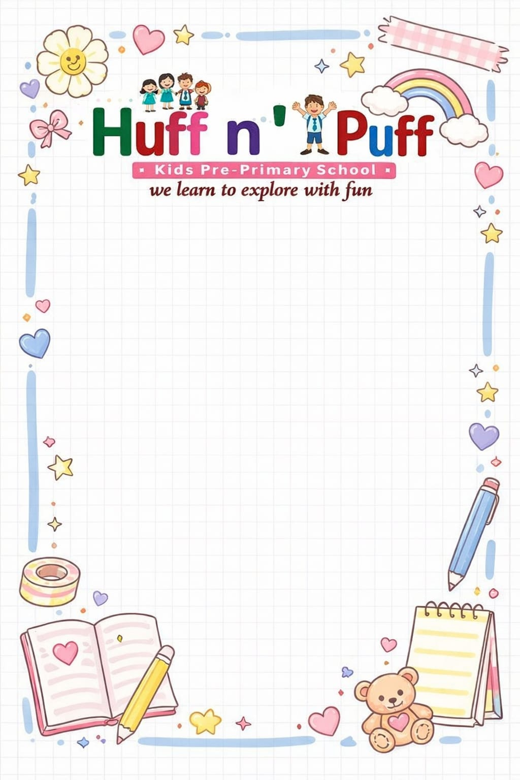
Nursery Syllabus(Session 2026-2027)
April
English (Written): Learn to Write Page no. 3 to 15, Capital A to D letters.
English (Oral): Tune in to alphabet Aa to Ee capital and small letter.
English (Poem): Mixed Rhymes – I see the moon, Johnny, Johnny, Roses are red.
Hindi (Written): Write अक्षर Page no. 3 to 15 चित्र देखकर सही अक्षर पर गोला लगाओ, स्वर अ से ई तक का अभ्यास।
Hindi (Oral): अक्षर अ से ऊ तक का अभ्यास।
Hindi (Poem): चिड़िया, सूरज निकला।
Math’s (Written): Comparisons Big and Small Page no. 12 to 19, Counting 1 to 4.
Math’s (Oral): Counting 1 to 20, Backward Counting 10 to 1.
E.V.S (O): My body parts, Fresh fruits.
G.K (O): General Awareness-My family, me and myself.
Drawing: Art & Craft Page no. 1 to 5.
May
English (Written): 1. Capital letter F to K.
2. Learn to write Page no. 16 to 23, Look at the picture and match the First alphabet. (Page no. 24-31 holiday homework)
English (Oral): Tune in to alphabet Aa to Jj capital and small letter.
English (Poem): I have a little nose, Twinkle - Twinkle little star, rain on the green grass.
Hindi (Written): स्वर अ, आ, इ, ई लिखने का अभ्यास अक्षर को अक्षर से मिलाओ, अक्षर को सही चित्र से मिलाओ, अक्षर पर गोला लगाओ, स्वर उ से ऐ तक का अभ्यास | (Page no. 16-23 holiday homework)
Hindi (Oral): ऋ से अ: तक का अभ्यास।
Hindi (Poem): मछली जल की रानी है, ये मेरी गुड़िया रानी है।
Math’s (Written): Counting 1 to 5 with dots, Tall and short, match the same number, Circle the number 3, Counting 1 to 10. (20-25 holiday homework)
Math’s (Oral): Counting 1 to 40, Backward Counting 15 to 1.
E.V.S (O): Colours, My classroom.
G.K (O): Fun time, This is me.
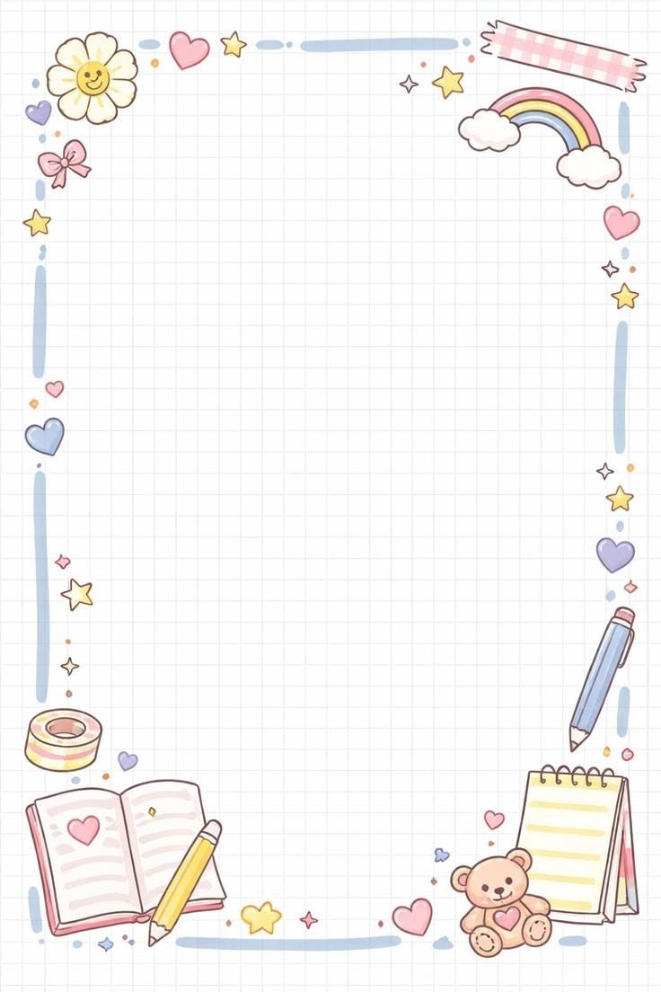
June
Summer Vacation
(24th May 2025 – 30th June 2025)
July
English (Written): Match the alphabet A to H, Circle the alphabet, Matching pictures, Capital L to Q letters.
English (Oral): Tune in to alphabet Aa to Pp capital and small letter.
English (Poem): Jingle bells, Jack be nimble, Lucy locket.
Hindi (Written): Learn to Write अक्षर Page no. 24 to 33 चित्र देखकर सही अक्षर पर गोला लगाओ, स्वर ओ से अ:, व्यंजन क से घ।
Hindi (Oral): अक्षर क से ञ तक का अभ्यास।
Hindi (Poem): बादल, चंदा मामा।
Math's (Written): More less, heavy and light, Writing book Page no. 26 to 33, Missing numbers, Counting 11 to 15 & backward Counting 10 to 1.
Math's (Oral): Counting 1 to 50, Backward Counting 20 to 1, Table of 2, Numbers name 1 and 2.
E.V.S (O): Classroom objects, Fruits.
G.K (O): This is my family, small family and large family.
Drawing: Page no. 9 to 11.
August
English (Written): Page no. 34 to 42, Matching, Fill in the blanks, Capital R to W letters.
English (Oral): Tune into alphabet Aa to Vv capital and small letter.
English (Poem): Brother John, Bits of paper, Two Little dicky birds.
Hindi (Written): Learn to write अक्षर Page no. 34 to 42 अक्षर को अक्षर से मिलाओ, व्यंजन 'ङ' से 'ञ'।
Hindi (Oral): 'ट' से 'न' तक का अभ्यास।
Hindi (Poem): मेरा घर, गुब्बारे वाला।
Math's (Written): Page no. 34 to 42, Count and write the number, Counting 16 to 20.
Math's (Oral): Counting 1 to 60, Backward Counting 30 to 1, Table of 3, Numbers name 3 and 4.
E.V.S (O): Vegetables, food.
G.K (O): My house, Rooms in a house.
Drawing: Page no. 13 to 16.
September
First Term Examination
(08th Sep 2025 till 20th Sep 2025)
October
English (Written): Alphabet skill book Page no. 42 to 49, what comes after, before and between, Capital letter X to Z letters & small Letters a to d.
English (Poem): Cobbler-cobbler, after a bath, Hickery Dickery Dock.
English (Oral): Aa- Zz.
Hindi (Written): Akshar Gyan Page no. 42 to 49 पहले बाद और बीच का अक्षर लिखें। व्यंजन ट से त तक।
Hindi (Oral): 'प' से 'र' तक का अभ्यास।
Hindi (Poem): चिंटी और हाथी, मम्मी-पापा।
Math's (Written): Page no. 42 to 49, In-out, what comes after, between and before & Counting 21 to 30 backward counting 20 to 11, maths 1-100.
Math's (Oral): Counting 1 to 60, Numbers name 5 and 6.
E.V.S (O): Pet and domestic animals, animals in the farm.
G.K (O): Vehicles, Toys.
Drawing: Page no. 17 to 20.
November
English (Written): Page no. 50 to 60, Circle the odd one letter, Small letter ‘e’ to ‘j’.
English (Oral): Tune in to alphabet Aa to Zz capital and small letter.
English (Poem): Dancing is not hard, Row – Row-Row your back, Ding-dong bell.
Hindi (Written): अक्षर Page no. 50 to 75 अलग अक्षर पर गोला लगाओ। व्यंजन 'थ' से 'फ' तक।
Hindi (Oral): 'ल' से 'ज्ञ' तक का अभ्यास।
Hindi (Poem): सूरज, चांद, तारे, आम रसीले।
Math's (Written): Math’s-Page no. 50 to 60, Counting 31 to 40, backward counting 20-11.
Math's (Oral): Counting 1 to 80, Backward Counting 35 to 1, Table of 2, 3, Numbers name 7 and 8.
E.V.S (O): wild animals, birds.
G.K (O): Vehicles, Toys.
Drawing: Page no. 21 to 24.
December
Winter Vacations: (24th Dec 2025 to 5th January 2026)
Unit Test: (1st Dec 2025 till 6th Dec 2025)
English (Written): Page no. 61 to 68 & small letter k to p.
English (Oral): Aa to Zz.
English (Poem): Rhymes – Jack and Jill, Baa-Baa black sheep, I like to play.
Hindi (Written): Learn to write अक्षर Page no. 76 to 96 & व्यंजन ब से ल।
Hindi (Poem): बच्चे प्यारे, फूल, ईश्वर के गुण गाये।
Math's (Written): Page no. 56 to 59, Addition, subtraction, 41 to 50 & 30 to 21.
Math's (Oral): Counting 1 to 100, Backward Counting 40 to 1, Table of 4, 5, Numbers name 9 and 10.
E.V.S (O): Flowers, Season, feelings.
G.K: Clothes, Festival, Action Words.
Drawing: Page no. 25 to 29.
January
English (Written): Page no. 69 to 72, small letter q to v.
English (Oral): Aa to Zz.
English (Poem): I Clean up song, Cock-a-doodle doo, Lollipop, Traffic Light.
Hindi (Written): Page no. 85 to 96, व्यंजन व से ज्ञ तक।
Hindi (Oral): अ से ज्ञ तक।
Hindi (Poem): तोता हूँ भाई तोता हूँ, केला खाया, मीठी बोली।
Math's (Written): Page no. 69 to 72, backward counting 30 to 21.
Math's (Oral): Backward counting 40-31, Table 2, 3 and counting 1-100.
G.K: R.w., Magic word.
Drawing: Page no. 30 to 32.
February
English (Written): small letter w – z.
All Subject Revision Work: (1st Feb 2026 till 3rd Mar 2026)
March
Final Term Examination
(9th Mar 2026 till 18th Mar 2026)
Math's (Oral): Counting 1 to 60, Numbers name 5 and 6.
E.V.S (O): Pet and domestic animals, animals in the farm.
G.K (O): Vehicles, Toys.
Drawing: Page no. 17 to 20.
November
English (Written): Page no. 50 to 60, Circle the odd one letter, Small letter ‘e’ to ‘j’.
English (Oral): Tune in to alphabet Aa to Zz capital and small letter.
English (Poem): Dancing is not hard, Row – Row-Row your back, Ding-dong bell.
Hindi (Written): अक्षर Page no. 50 to 75 अलग अक्षर पर गोला लगाओ। व्यंजन 'थ' से 'फ' तक।
Hindi (Oral): 'ल' से 'ज्ञ' तक का अभ्यास।
Hindi (Poem): सूरज, चांद, तारे, आम रसीले।
Math's (Written): Math’s-Page no. 50 to 60, Counting 31 to 40, backward counting 20-11.
Math's (Oral): Counting 1 to 80, Backward Counting 35 to 1, Table of 2, 3, Numbers name 7 and 8.
E.V.S (O): wild animals, birds.
G.K (O): Vehicles, Toys.
Drawing: Page no. 21 to 24.
December
Winter Vacations: (24th Dec 2025 to 5th January 2026)
Unit Test: (1st Dec 2025 till 6th Dec 2025)
English (Written): Page no. 61 to 68 & small letter k to p.
English (Oral): Aa to Zz.
English (Poem): Rhymes – Jack and Jill, Baa-Baa black sheep, I like to play.
Hindi (Written): Learn to write अक्षर Page no. 76 to 96 & व्यंजन ब से ल।
Hindi (Poem): बच्चे प्यारे, फूल, ईश्वर के गुण गाये।
Math's (Written): Page no. 56 to 59, Addition, subtraction, 41 to 50 & 30 to 21.
Math's (Oral): Counting 1 to 100, Backward Counting 40 to 1, Table of 4, 5, Numbers name 9 and 10.
E.V.S (O): Flowers, Season, feelings.
G.K: Clothes, Festival, Action Words.
Drawing: Page no. 25 to 29.
January
English (Written): Page no. 69 to 72, small letter q to v.
English (Oral): Aa to Zz.
English (Poem): I Clean up song, Cock-a-doodle doo, Lollipop, Traffic Light.
Hindi (Written): Page no. 85 to 96, व्यंजन व से ज्ञ तक।
Hindi (Oral): अ से ज्ञ तक।
Hindi (Poem): तोता हूँ भाई तोता हूँ, केला खाया, मीठी बोली।
Math's (Written): Page no. 69 to 72, backward counting 30 to 21.
Math's (Oral): Backward counting 40-31, Table 2, 3 and counting 1-100.
G.K: R.w., Magic word.
Drawing: Page no. 30 to 32.

Final Term Examination
(9th Mar 2026 till 18th Mar 2026)

February
English (Written): small letter w – z.
All Subject Revision Work: (1st Feb 2026 till 3rd Mar 2026)

March
Final Term Examination
(9th Mar 2026 till 18th Mar 2026)

