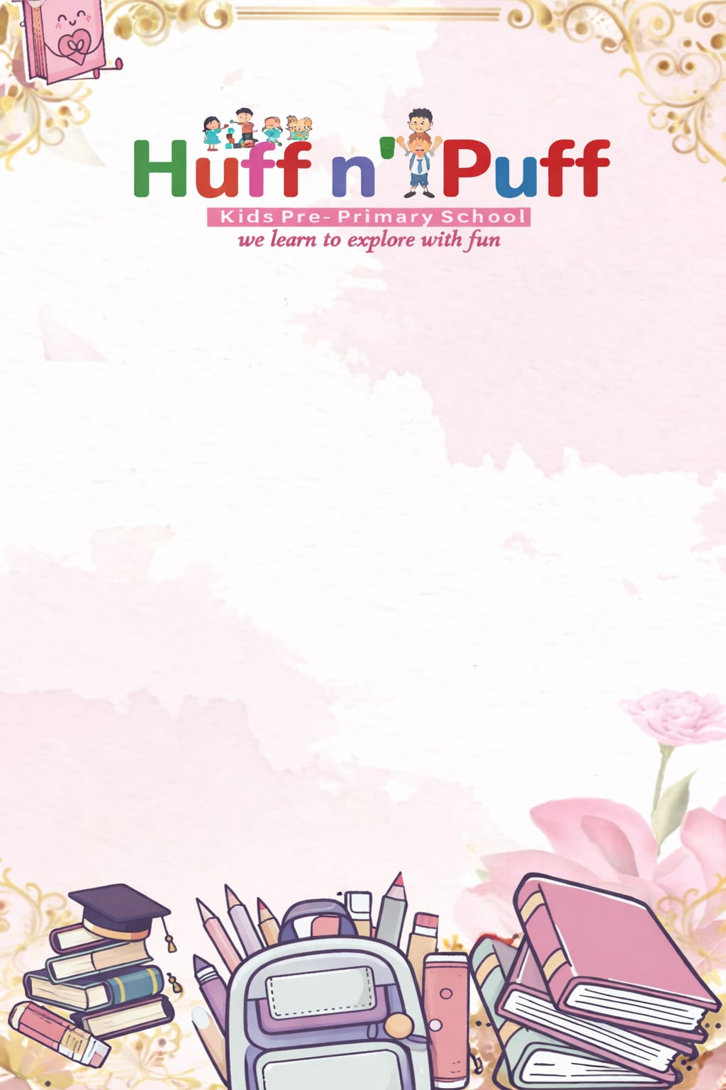
U.K.G Syllabus(Session-2026-2027)
April
English (Written): Pages 3–6: Capital & small letters, Dot-to-dot alphabet (vowels a–f)
English (Oral):Pages 2–3: Star Light Star Bright , Two Little Ducks
English (Phonics): Pages 3–5: About my name, vowels
English Cursive: Pages 3–5: Strokes
Hindi (Swar Gyan): Pages 4–8
Hindi (Swar Sulekh): Pages 3–7: Khel khel mein, picture-based writing
Hindi (Oral): Pages 31–32: Prarthna, Aaloo
Maths: Pages 3–8:, Fun time , Sorting , Comparisons , Tables (2 & 3)
EVS: Lessons 1 & 2: About me, Body parts
GK: Lessons 9 & 13: Colours, Fruits, Pages 20–22, 28–29
Art & Craft: Pages 1–3: Boat, Patterns, Starfish
May
English (Written): Pages 6–18: Alphabet f–z, vowels & consonants
English (Phonics): Pages 6–10: Short & long ‘o’ sound
English (Cursive): Pages 6–9: Trace & write
English (Rhymes): Pages 4–5: My School , Five Little Monkeys
Hindi (Swar Gyan): Pages 9–13: 3–4 letter words, joining letters
Hindi (Swar Sulekh): Pages 8–11: Word formation (without matra)
Hindi (Geet):Pages 33–34: Circus, Dhoop
Maths: Pages 9–16: Thick/thin, left/right , Big/small comparisons, Numbers 1–50 , Table of 4
EVS: Lessons 4 & 5: Sense organs, Family
GK: Lessons 10 & 15: Vegetables, Flowers
Art & Craft: Pages 4–6: Flower pot, Balloons, Mango
Summer Vacation
20 May – 20 June 2024

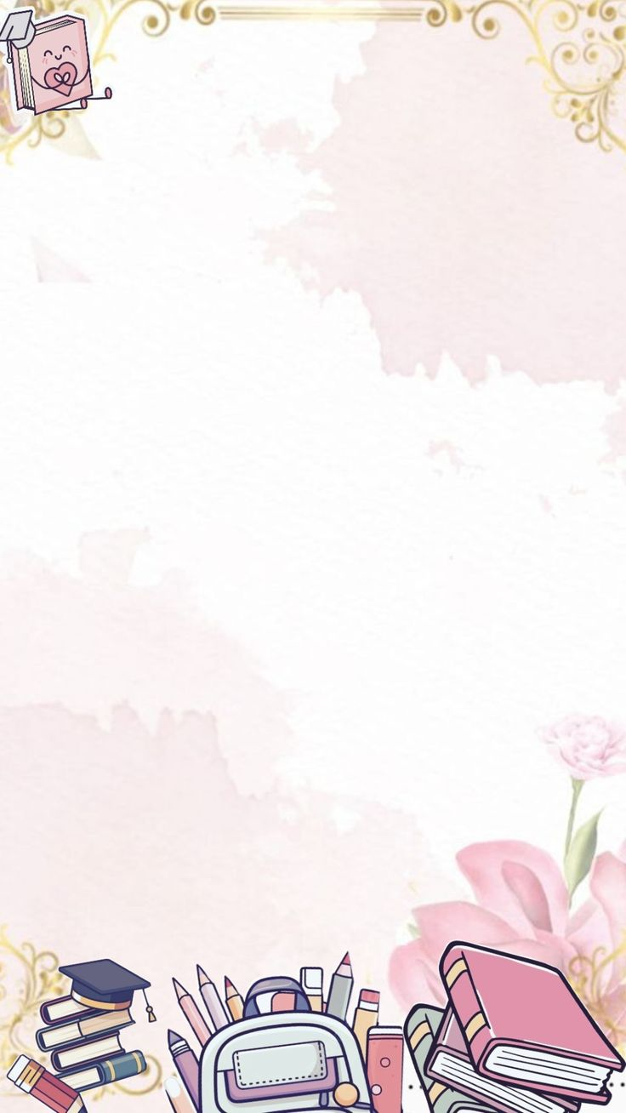
July
English Literacy: Pages 19–35: Vowels i, o, u, rhyming words
English (Phonics): Pages 11–15: Short & long ‘e’ sound
English (Cursive): Pages 10–15
English (Rhymes) : Pages 6–8: Rainbow , Little Polly Parrot , Three Little Fish
Hindi (Swar Gyan): Pages 14–21: Matra, word formation
Hindi (Swar Sulekh): Pages 12–17
Hindi (Geet): Pages 35–37
Maths: Pages 17–30: Backward counting , Before/after/between , Table of 4
EVS: Lessons 3 & 11: Cleanliness, Animals
GK: Lessons 6 & 7: School & places
Art & Craft: Pages 7–9: Park, Pizza, Cloud
August
Englis Literacy: Pages 36–45: Magic ‘e’ , Use of a/an , Essay: Myself (5 lines)
English (Phonics): Pages 16–20
English (Cursive): Pages 17–23
English (Rhymes): Pages 9–11
Hindi (Swar Gyan): Pages 22–33: Matra + word formation
Hindi (Swar Sulekh): Pages 18–20
Hindi (Geet): Pages 38–39
Maths: Pages 31–45: Greater/less/equal , Ascending/descending , Shapes
EVS: Lessons 12 & 14: Healthy habits, Plants
GK: Lessons 8 & 15
September
First Term Examination
07th Sep 2026 to 19Sep 2026
October
English Literature: Pages 46–55: One & many , Verb: is, am, are , This & that
English (Phonics): Pages 21–25: Short & long ‘o’
English (Cursive): Pages 24–31
English (Rhymes): Pages 12–14: Muffin Man , Pizza Song , Big Yellow Bus
Hindi (Swar Gyan): Pages 34–45
Hindi (Sulekh): Pages 26–33
Hindi (Geet): Pages 40–41: Traffic Signal
Maths: Page no: 46 to 56, Ordinal number, numbers name, 51-100 counting in tens and ones.
Evs: Page no. 18 & 19 , Birds & Insects.
G.k: 1 to 16

November
English (Literacy): Page no. 56–68: These and those, use of he/she, use of her/his, opposite words
English (Phonics): Page no. 26–33: Short and long ‘u’ sound, dr, tr, br and cr sound
English (Writing): Pages 32–40: Trace and write the letter
English (Rhymes): Pages 15–18: Old mother Hubbard, Giraffe, giraffe apples, Ten little fingers
Hindi (Swar Gyan): Page no. 46–52: Matrao ka gyan, chitron ko dekhkar, shabdo ko pura kijiye, Chandra bindu/ anuswar
Hindi (Swar Sulekh): Page no. 34–41: Trace kijiye aur likhiye
Hindi (Geet): Page no. 42–43: Rasgulle par Bhagat Singh
Maths: Page no. 57–64: Addition, subtraction, Tables 2–6
E.V.S.: Lesson no. 22, 28
G.K.: Lesson no. 21, 23: Gadgets, games
Art & Craft: Lesson no. 16–22: Truck, picnic, tree, snowy parrot

December
Unit Test
01 Dec 2024 – 07 Dec 2024
English (Literacy): Page no. 69–76: Opposite words, action words, what are adjectives
English (Phonics): Page no. 34–36: bl, cl, fl and gl sound
English (Writing): Page no. 41–50: Trace and write the letter
English (Rhymes): Page no. 19–22: Pussy Cat, Aeroplane, King of the Jungle, Peter Peter, Pumpkin Eater, Little Boy Blue
Hindi (Swar Gyan): Page no. 51–54: Ek paden, dino ke naam
Hindi (Swar Sulekh): Page no. 42–50: Trace kijiye aur likhiye
Hindi (Geet): Page no. 43: Bhagat Singh
Maths: Page no. 71–76: Multiplication, Tables 2–8
E.V.S.: Lesson no. 19, 30: Transport, Exercise
G.K.: Lesson no. 24, 25: Transport, Exercise
Art & Craft: Page no. 23–25: Caterpillar, fruits, beehive
January
English (Literacy): Page no. 77–82: Preposition, making pairs, rhyming (I, II)
English (Phonics): Page no. 37–40: ‘oo’ and ‘ee’ sound
English (Writing): Page no. 50–60: Trace and write the letter
English (Rhymes): Page no. 23–24: Shoo Spider, There was an old woman
Hindi (Swar Gyan): Page no. 55–56: Gintiyan aur mahine ke naam
Hindi (Swar Sulekh): Page no. 51–58: Pura abhyas karya
Hindi (Geet): Page no. 44: Pustak
Maths: Page no. 77–85: Division of numbers, clock song, telling time
E.V.S.: Lesson no. 31, 32: Festivals, Our Country India
G.K.:Lesson no. 26, 27: People who help us, places of worship
Art & Craft: Page no. 26–28: Backpack, snail, clown

February
English (Literacy): Page no. 83–88: Question words, time, days, season, months
English (Phonics): Revision work
English (Writing): Page no. 60–70: Trace and write the letter
English (Rhymes): Page no. 25–26: The Swing, The Little Turtle
Hindi (Swar Gyan): Revision work
Hindi (Swar Sulekh): Page no. 59–72: Trace kijiye aur likhiye
Hindi (Geet): Revision work
Maths: Page no. 86–90: Roman numbers, skip counting, our currency
E.V.S.: Revision work
G.K.: Revision work
Art & Craft: Page no. 29–30: Flower, house

March
Final Term Exam
01st March to 19 March 2027

