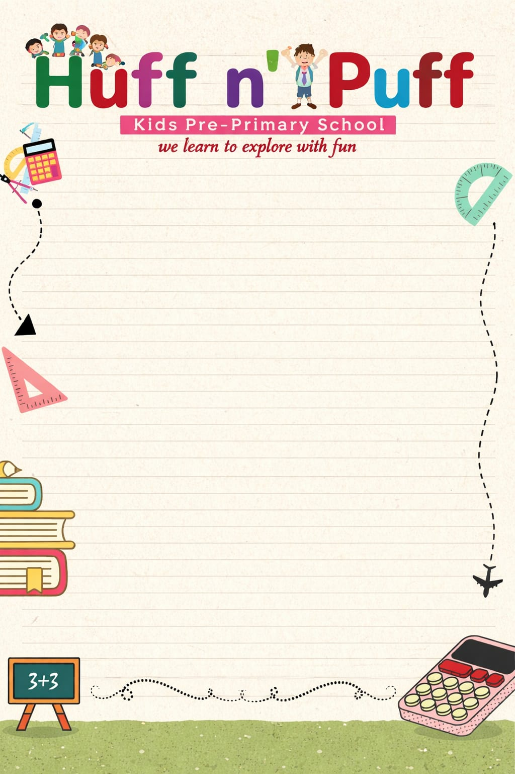
Class 2nd Syllabus(Session-2026-2027)
APRIL
हिन्दी: पाठ - 1 अच्छे-अच्छे काम करो
हिन्दी व्याकरण: पाठ - 1 भाषा, पाठ - 2 वर्ण और वर्णमाला
English (Reader): Ch-1 Be on Time
English (Grammar): Ch-1 Alphabetical order, Ch-2 Naming Words
EVS: Ch-1 My body
Maths: Ch-1 Numbers up to 1000
G.K: Ch-1 Animals in Group, Ch-2 Products from Animals, Ch-3 Different Leaves, Ch-4 Parts of a Plant
Moral Values: Ch-1 The Little Seed's Journey
Computer: Ch-1 More about computers

MAY

हिन्दी: पाठ - 2 सच की जीत
हिन्दी व्याकरण: पाठ - 3 स्वरों की मात्राएं
English (Reader): Ch-2 The Smart Kid
English (Grammar): Ch-3 Nouns (Common and Proper)
EVS: Ch-2 My Family
Maths: Ch-2 Addition
G.K: Ch-4 Eating Habits of Animal, Ch-5 Incredible India
Moral Values: Ch-2 The secrets of friends
Computer: Ch-2 Parts of a computer
Drawing: (2) Duck, (3) Circle (Ball), (4) Alarm Clock

JUNE
"Summer Vacations"
20th May to 20th June

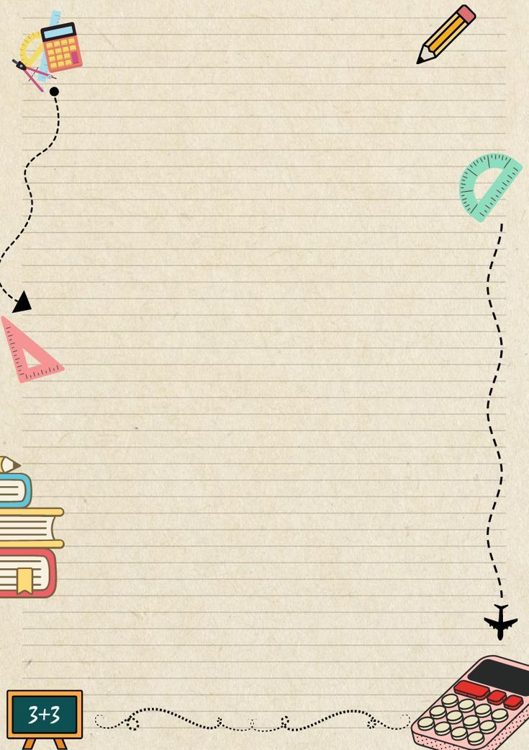
JULY
हिन्दी: पाठ - 3 सबक, पाठ - 4 एकता में बल है, पाठ - 5 बुद्धिमान दुकानदार
हिन्दी व्याकरण: पाठ - 4 संयुक्त व्यंजन, पाठ - 5 संज्ञा, पाठ - 6 लिंग
English (Reader): Ch-3 Animals in the farm
English (Grammar): Ch-4 Nouns (Countable and uncountable), Ch-5 Nouns (Singular and Plural), Ch-6 Nouns (Male and Female), Ch-7 Pronouns
EVS: Ch-3 Animals Around us, Ch-4 Plants around us
Maths: Ch-3 Subtraction, Ch-4 Multiplication
G.K: Ch-7 The Taste of India, Ch-8 Famous Indian Writers, Ch-9 Famous Places of the world
Computer: Ch-3
AUGUST
हिन्दी: पाठ - 6 कौआ और सुराही, पाठ - 7 मीठे बोल, पाठ - 8 चांद और तारा
हिन्दी व्याकरण: पाठ - 7 वचन, पाठ - 8 सर्वनाम, पाठ - 9 विशेषण
English (Reader): Ch-4 Visit to a fair
English (Grammar): Ch-8 Possessive Adjective, Ch-9 A, An and The, Ch-10 Action Words (In present)
EVS: Ch-5 Food we eat, Ch-6 Water
Maths: Ch-5 Division, Ch-6 Fractions
G.K: Ch-10 Famous Sculptures Gallery, Ch-11 Parliaments Around the world
Moral Values: Ch-3 The last minute rush
Computer: Ch-4 Exploring Windows
Drawing: (6) Piano, (7) Letter A, (8) Boy, (9) Dinosaur, (10) Magical Dot, (11) Parrot
September
"It's Exam Time"
07th Sep 2026 to 19Sep 2026

OCTOBER
हिन्दी: पाठ - 10 चिड़ियाघर की सैर, पाठ - 11 प्यारा भारत
हिन्दी व्याकरण: पाठ - 10 क्रिया, पाठ - 11 पर्यायवाची शब्द
Moral Values: Ch-4 The Little Earth Keeper
Computer: Ch-5 Activities using Keyboard and Mouse
G.K: Ch-12 The Puppet show, Ch-13 Famous Theatre Artists, Ch-14 Theatre For Kids, Ch-15 The Piano, Ch-16 Famous musical shows
Drawing: (12) Crab, (13) Butterfly, (14) Clown, (15) Crow, (16) Sailboat
NOVEMBER
हिन्दी: पाठ - 12 रेल का खेल, पाठ - 13 स्वस्थ जीवन
हिन्दी व्याकरण: पाठ - 12 अनेक शब्दों के लिए एक शब्द, पाठ - 13 विलोम शब्द
English (Reader): Ch-5 Be Alert, Ch-6 King Robert Bruce
English (Grammar): Ch-11 Action words (In past), Ch-12 Describing words, Ch-13 Use of Is, am, are, Ch-14 Use of was and were
EVS: Ch-7 Our Houses, Ch-8 Our Clothes
Maths: Ch-7 Measurement, Ch-8 Shapes
G.K: Ch-17 Music in nature, Ch-18 Famous Dancers of India, Ch-19 Dance for Fitness and Fun, Ch-20 Different Dance step
Moral Values: Ch-5 Our Flag, Our Pride
Computer: Ch-6 More on Tux Paint
Drawing: (17) Love and Key, (18) Baby Elephant, (19) Half and Half, (20) Octopus, (21) Cat, (22) Monkey
DECEMBER
Christmas Holiday 23rd Dec to 27 December 2026
हिन्दी: पाठ - 14 पौधों की कहानी, पाठ - 15 कौन सिखाता है?
हिन्दी व्याकरण: पाठ - 14 दिन और महीने, पाठ - 15 चित्र वर्णन
English (Reader): Ch-7 Flying Kites, Ch-8 A Tasty Tale
English (Grammar): Ch-15 Use of Is, am, are with verb + ing form, Ch-16 Use of was and were with verb + ing form, Ch-17 Use of Shall and Will, Ch-18 Use of Has, Have and Had
EVS: Ch-9 Places in my neighborhood, Ch-10 Celebrating Festivals
Maths: Ch-9 Patterns, Ch-10 Time
G.K: Ch-21 Machines in Use, Ch-22 Connecting with others, Ch-23 Sports Equipments, Ch-24 Famous TV Serials, Ch-25 Seasons
Moral Values: Ch-6 The Magic of self Discipline
Computer: Ch-7 Introduction to wordpad
Drawing: (23) Tomato, (24) Balloons, (25) Sunflower
JANUARY
Winter Vacation - 1st January to 10th to January 2026
हिन्दी: पाठ - 16 हमारा राष्ट्रीय ध्वज (तिरंगा), पाठ - 17 शुक्रिया फल
हिन्दी व्याकरण: पाठ - 16 कहानी लेखन, पाठ - 17 गिनती, पाठ - 18 वाक्य रचना
English (Grammar): Ch-19 Adverb, Ch-20 Opposite Words, Ch-21 Wh-Question Words, Ch-22 Prepositions
EVS: Ch-11 Ways of Recreation, Ch-12 Means of Communication
Maths: Ch-10 Time
G.K: Ch-26 The Solar system, Ch-27 Our Environment, Ch-28 Start Practising Yoga, Ch-29 Yoga for kids, Ch-30 The Mountain Pose
Moral Values: Ch-7 Let's play Fair Judgement
Computer: Ch-8 Learning logic with Kidlo, Ch-9 More on Artificial Intelligence Projects
Drawing: (26) Square, (27) Dog, (28) Lion, (29) Leaf, (30) Paper (collage)
FEBRUARY
Revision & Model Test Papers
March
"It's Exam time"
01st March to 19 March 2027

