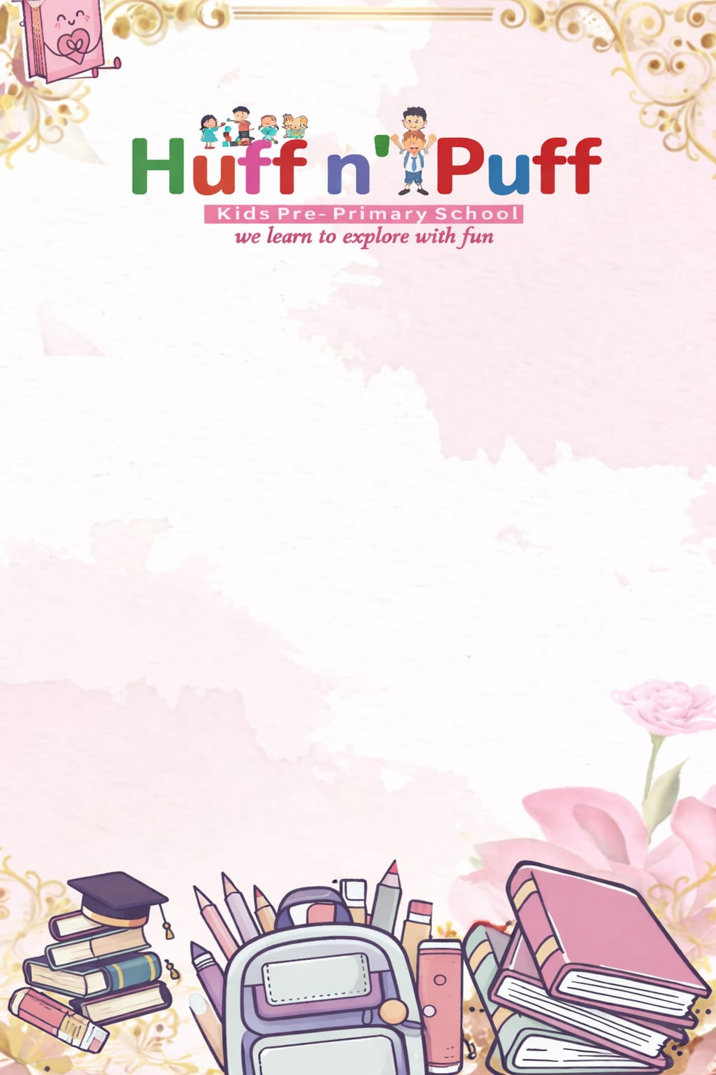
Class-3rd Syllabus (session 2026-2027)

April
हिन्दी भाषा: मैं हूँ पानी, शिष्टाचार, पेड़ है धरती की शान
हिन्दी व्याकरण: भाषा, वर्ण और वर्णमाला, शब्द और वाक्य
English R [Reader]:Tommy’s Apple tree, Lost and found
English G [Grammar]:Sentences, Types of sentences, Subject and Predicate
Maths: Ch-1 4 digit number, Ch-2 Addition
E.V.S: Family and friends, Going to the mela
G.K: Amazing Animals of the World, Life under water, Amazing Birds, Amazing Plants and Trees
Moral Science: Arjun and the Endless Craving
Computer : Working of a Computer
Drawing: Page no - 3, 4, 5, 6

May
हिन्दी भाषा: घनिष्ट मित्रता, कालिदास
हिन्दी व्याकरण: नाम वाले शब्द (संज्ञा), स्त्री - पुरुष (लिंग)
English R [Reader]: An Act of Kindness, The Friendly Cow
English G [Grammar]: Nouns: Singular and Plural
Maths: Ch-3 Subtraction, Ch-4 Multiplication
E.V.S: Celebrating festivals, getting to know plants
G.K: Languages of India, India Got Independence
Moral Values: Honesty is the best Police
Computer: Operating System Basics
Drawing: Page no - 7, 8

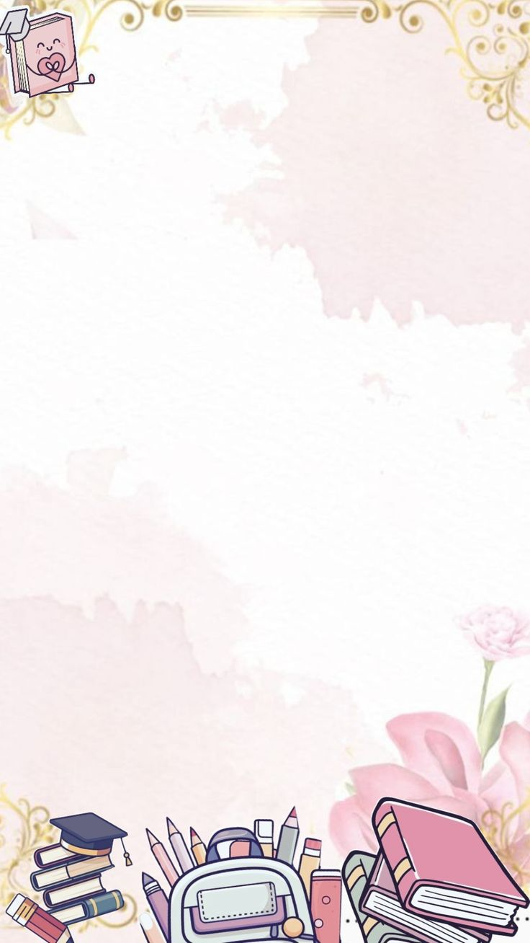
May - June
Summer Vacation
20th May to 20th June

July
हिन्दी भाषा: समस्या का समाधान, पशु-बाघ, हीरा और कोयल
हिन्दी व्याकरण: एक - अनेक (वचन), सब नामो के लिए (सर्वनाम), विशेषता बताने वाले शब्द (विशेषण)
English R [Reader]:The Beauty of Nature, How Beautiful the World Is, Peter Penguin’s New Suit, Zero Hunger Healthy food
English G [Grammar]:Nouns - Countable and unCountable, Nouns - Masculine and feminine, Pronouns - Personal and Neutral
Maths: Ch-5 Division
E.V.S: Plants and animals live Together, = Living in Harmony
G.K: Olympic Medalist of India, Nobel Prize winners of India, Women Power, The Great Rivers of India, Continents and Oceans, Wonders of the world
Moral Values: The Sense of Responsibility
Computer: Computer Files and Folders
Drawing: Page no 9 to 12

August
Hindi भाषा: हीरा और कोयल, जो मैं भी चिड़िया बन जाती, रबड़
हिन्दी व्याकरण: काम बताने वाले शब्द (क्रिया), अशुद्धि शोधन
English R [Reader]: The Greedy Woman, Friends are forever
English G [Grammar]: Personal Pronouns and Personal Adjectives (Possessive Case), Demonstrative Pronouns, Tenses of Verbs
E.V.S: Water: A Precious Gift
Maths: Ch-7 Fraction, Ch-8 Measurements
G.K: International Days, The Global Leaders, Storytelling Magic, Girish Karnad: A Great Storyteller, Elements of Drama
Moral Sc [Science]: The Magic of kind words
Computer: Introduction to MS Word 2021
Drawing: Page no - 13 to 16

September
"Its Exam Time"
(First Term Exam)
07th Sep 2026 to 19Sep 2026
October
Hindi भाषा: कबीर के दोहे, बक्से का रहस्या, स्वच्छत्ता
हिन्दी व्याकरण: सामानार्थी शबद (पर्यायवाची), वीरितार्थी शब्द, अनैक शब्दो के लिए एक शब्द
English R [Reader]:The perfect wish, little ants
Eng - G [English Grammar]: Adjectives, Adverbs, Prepositions.
Maths: Ch-8 Money, Ch-9 Time
E.V.S: Food We Eat
G.K: Musical instruments, Lets Sing a song, Make your own orchestra, Move freely, What the actions say?, Posture of hands and finger, Classical dance of india.
Moral Science: The courage to do right, the reward of patience.
Computer: Editing And Formating
Drawing: Page no - 17to 21

November
Hindi भाषा: चंद्रयान, देख के चलो
Hindi व्याकरण: मुहावरे, संवाद लेखन, चित्र वर्णन
English R [Reader]: Who is stronger - Sun or Wind?, The Daffodil flower
English G [Grammar]: Conjunctions, Interjections, Use of Articles, Essay
E.V.S: Staying healthy and happy, the world of things
Maths: Ch-11 Geometry, Ch-11 Symmetry
G.K: Inventions that make life easier, Inside a computer,Robots in daily life, Sports legends, sports grounds, Famous Musicians, Cups and trophies, Natural resources, Living and non-living things
Moral Sc [Science]: Sardar Patel the architect of unity, Everyone deserves respect.
Computer: Internet services
Drawing: Page no 22 to 27

December
Christmas Holiday 23rd Dec to 27 December 2026
Hindi भाषा: भाषा विश्वगुरु-भारत,
Hindi व्याकरण: कहानी लेखन, अनुछेद लेखन
English R [Reader]: Clean India, Save trees
English - G [Grammar]: Punctuation marks, comprehension, composition, story writting.
E.V.S: Making things
Maths: Ch-12 Data handling

G.K: History of Yoga, types of yoga, basic yoga poses, the world of books, sickness, emergency vehicles.
Moral Science: Anaya's thank you day
Computer: Thinking stepwise with robomind,
Drawing: Page no 28 to 33

Winter Vacation - 1st January to 10th to January 2026
January
Hindi भाषा: दशहरे की छुट्टियां, आदर्श प्रश्न पत्र-1 & 2
Hindi व्याकरण: पत्र लेखन, निबंध लेखन, आदर्श प्रश्न पत्र-1 & 2
English R [Reader]: Chandrayaan: The moon mission, Model test Papers
English - G [Grammar]: Story writing, Letter writing, Application, Synonyms and Antonyms, Model Paper - 1, 2
E.V.S: Taking Charge of waste
Maths: Model test paper-1, 2
G.K: Riddles, Sources of food, Rewind your memory 1, 2
Moral Science: Priya's Kind Heart
Computer: Let’s Learn Scratch 3, AI Enabled Devices, Projects
Drawing: Page no 34 to 40

February
Revision work
March
"It's Exam Time"
(Final Term Exam)

