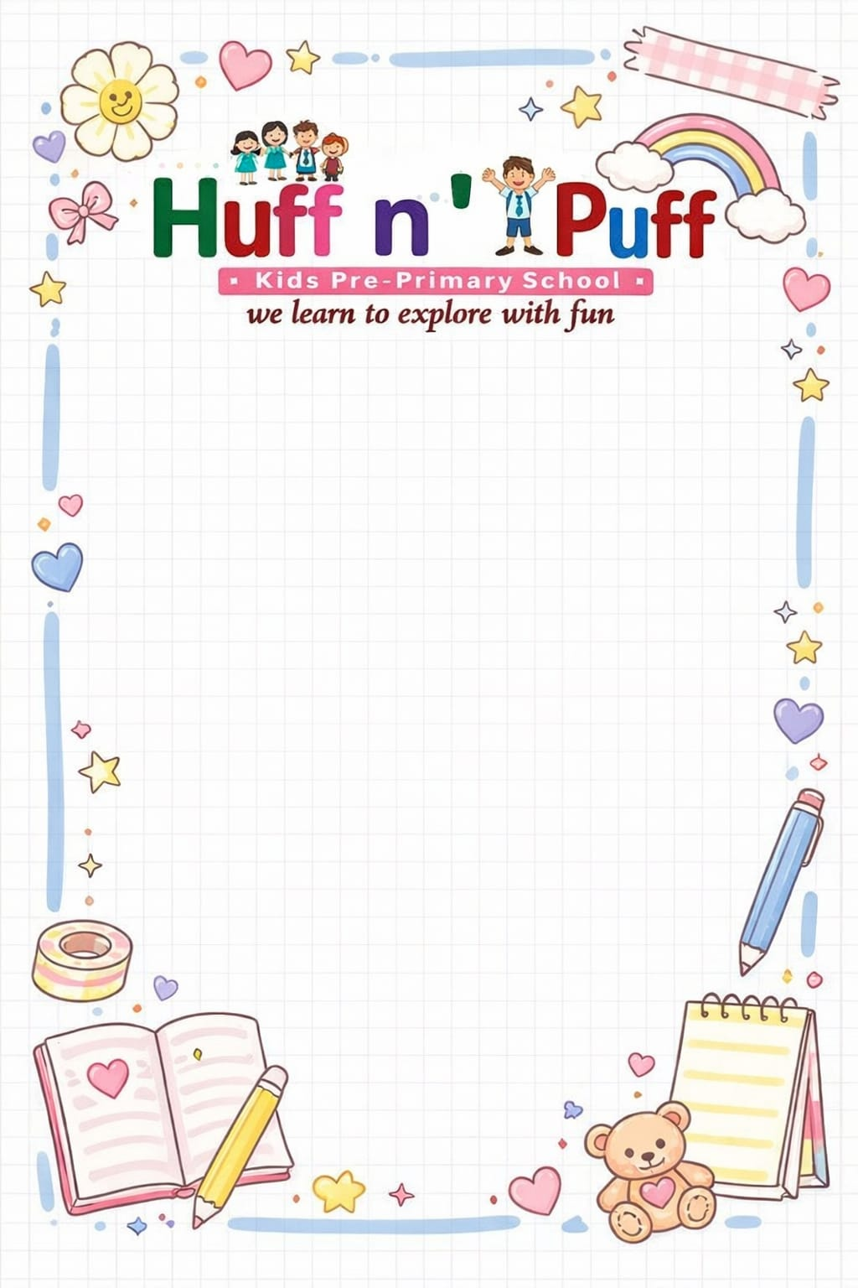

Session: 2026–2027
Class: IVth
Syllabus

APRIL

Hindi पाठ्यपुस्तक: पाठ–1 हिमालय
पाठ-2 प्राकृतिक वैद्य – नीम तथा तुलसी
Hindi व्याकरण: पाठ–1 भाषा, लिपि और व्याकरण
पाठ–2 वर्ण विचार
पाठ–3 शब्द विचार
English Reader: Chapter 1: The Blue Umbrella (A Child’s Wish)
English Grammar: Chapter 1: The Sentence
Chapter 2: Kinds of Sentence
Chapter 3: Noun and its Kinds
Maths :Chapter 1: 5-Digit Numbers
Chapter 2: Addition
General Knowledge and Moral Values: The Living World
Amazing Insects
Endangered Animals
Useful Plants
Plant Products
Moral Values: The Miser Man
E.V.S.: Chapter-1: Understanding Family Changes
Chapter-2: Understanding our Neighbourhood
Computer: Windows GUI Settings

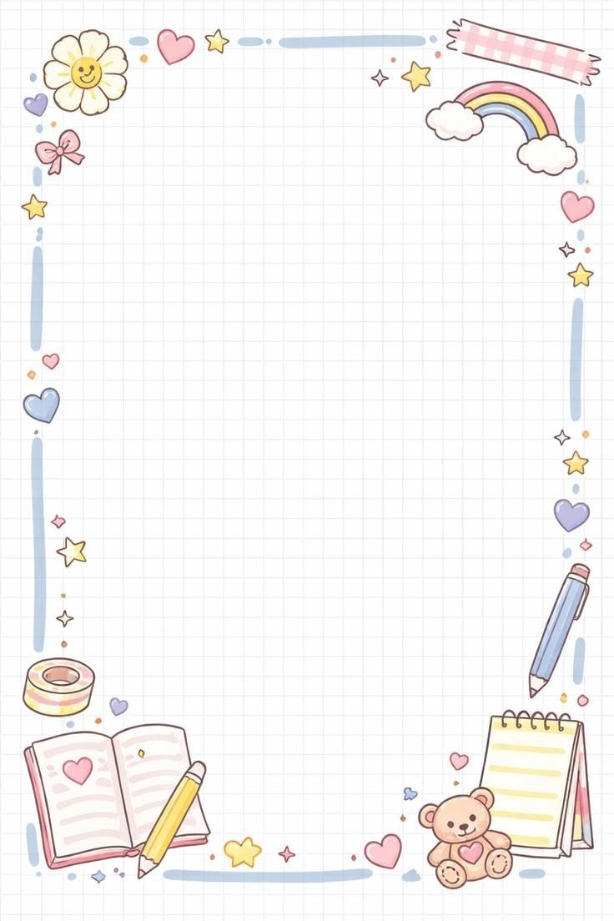

MAY

Hindi पाठ्यपुस्तक: पाठ–3 चिड़िया घर की सैर
पाठ–4 जल की उपयोगिता
Hindi व्याकरण: पाठ–4 संज्ञा
पाठ–5 लिंग
English Reader: Chapter 2: A New Opinion towards Discipline
(Always Speak Truth)
English Grammar: Chapter 4: Nouns – Singular and Plural
Chapter 5: Nouns – Countable and Uncountable
Maths: Chapter 3: Subtraction
Chapter 4: Multiplication
GK and Moral Values: Know Your Country
Presidents of India
The Train – Vande Bharat
Famous Monuments of India
Indian Dresses
Popular Banks of India
Moral Values: Vidyasagar’s Wisdom
E.V.S.: Chapter 3: People and Their Occupations
Chapter 4: Celebrating Together
Computer: Chapter 2: Data Storage in Computer

JUNE
“SUMMER VACATION”
(15th May 2026-30th June 2026)

JULY

Hindi पाठ्यपुस्तक: पाठ–5 बुद्धिमान की चतुराई
पाठ–6 अक्ल बड़ी या भैंस
पाठ–7 दो पहलवान
Hindi व्याकरण: पाठ–6 वचन बोध
पाठ–7 संज्ञा के स्थान पर सर्वनाम
पाठ–8 विशेषण बोध
पाठ–9 क्रिया
English Reader: Chapter 3: Dad’s Cellphone (Emotions)
English Grammar: Chapter 6: Noun – Gender
Chapter 7: Pronouns
Chapter 8: Verbs
Chapter 9: Adjectives
Maths: Chapter 5: Division
Chapter 6: Multiples and Factors
G.K. and Moral Values: (G.K).- Around the world
Great rivers of the world
Famous Travellers
Sanitation around the world
Theatre: Role-Camera-Action
Famous theatre personalities
Indian theatre: A long history
Importance of theatre in culture
Moral Values: Gajraj and the greatful mouse
E.V.S: Chapter 5: Amazing animals around us
Chapter 6: Exploring different plants
Computer: Chapter 3: Working with objects in MS Word 2021
Chapter 4: More features of MS Word 2021

AUGUST

Hindi पाठ्यपुस्तक: पाठ–8 दो चिड़ियाँ
पाठ - 9 अब्दुल कलाम की कलम से
हिंदी व्याकरण [Hindi Grammar]: पाठ - 10 काल - समय निर्धारण
पाठ - 11 कारक बोधक विभक्तियाँ
English Reader: Chapter 4: World environment day
(The leaves and the wind)
English Grammar: Chapter 10: Degree of comparison
Chapter 11: Adverbs
Chapter 12: Prepositions
Maths: Chapter: 7 Fractions
Chapter 8: Decimals
G.K and moral values: G.K: Indian classical music
The magic of music
Musical scores: A beginner’s guide
Dance and movements: Folk dance of India
India’s dance festivals
Dances around the world
Moral values: The clever rabbits and the hungry fox
E.V.S: Chapter 7: Weather and Seasons
Computer: Chapter 5: Introduction to power point

SEPTEMBER
“FIRST TERM
EXAMINATION”

OCTOBER
हिंदी पाठ्यपुस्तक [Hindi Textbook]: पाठ - 10 दो जूते
पाठ - 11 जो चाहो वह पा लो तुम
पाठ - 12 अपशकुन
हिंदी व्याकरण [Hindi Grammar]: पाठ - 12 अविकारी शब्द - अव्यय
पाठ - 13 शब्द शिल्प
English Reader: Chapter - 5 Brahmin and the Seven fairies (Try, Try Again)
English Grammar: Chapter - 13: Conjunctions
Chapter - 14: Interjections
Chapter - 15: Articles
Maths: chapter - 9 Measurement
Chapter - 10 Perimeter and Area
G.K. and Moral Values: G.K.: Science And Technology
Accidently Invented Things
What is Software
The Power of Social Media
October (cont.)
Moral values: A Gift of love and kindness
The Power of Hard work
E.v.s: chapter - 8 Growing and Preparing food
chapter - 9 The Story of Water
Computer: Chapter - 6 More About the Internet

NOVEMBER

हिंदी पाठ्यपुस्तक [Hindi Textbook]:पाठ - 13 चित्रकार का चित्र
पाठ - 14 वीर पृथ्वी सिंह
हिंदी व्याकरण [Hindi Grammar]: पाठ - 14 अनेक शब्दों के लिए एक
शब्द (वाक्यांश)
पाठ - 15 विराम - चिह्न
English Reader: Chapter - 6 Sun and Moon's Daughter
Ferdinand Frog and the Flea
English Grammar: Chapter - 16 Contractions
Chapter - 17 Punctuation Marks and Capitalisation
Chapter - 18 Tenses
Maths: Chapter - 11 Geometry
Chapter - 12 Time
G.K. and Moral Values: G.k.: Sports and resources
Amazing Sports Record Holders
The Pride of our Nation
Famous Animated Movies
Moral Values: Ritika's School Mistake
The Happy Fisherman
Computer: Chapter - 7 Developing Logic with robomind

E.v.s: Chapter - 10 Our Natural Resources

DECEMBER
English (Lit) – Lesson – 7 Wonderful Wizard of Oz and The
Best Pilot
English (Grammar) – Lesson – 15, 18 Articles, Tenses, Letter
Hindi – पाठ – 15, 16 कठिन शब्द, प्रश्न / उत्तर पूरा अभ्यास कार्य
Hindi (व्याकरण) – पाठ – 14, 19 anek shabd ke liye 1 shabd, nibandh –
samay ka sadupyog
Maths – Ex – 15 Data handling
E.V.S – Lesson – 11 Pollution
G.K – Page no – 8, 9, 36, 44, 45, 16, 21, 43 Our Surroundings,
Move Your Body
Computer – Lesson – 8, 9 More on Scratch 3, Evolution of
Artificial Intelligence

JANUARY

English (Lit) – Lesson – 8, 9 Kindness Repays Kindness and Kindness
to Animals, Do Not Break Promise, Word–Meaning, Q/A and Exercise
English (Grammar) – Lesson – 16 Contraction, Practice Papers
Hindi – पाठ – 17, 18 कठिन शब्द, प्रश्न / उत्तर पूरा अभ्यास कार्य
Hindi (व्याकरण) – पाठ – 15, 16 viram chinh, muhavare
Maths – Model test papers 1, 2
E.V.S – Lesson – 12 Waste Disposal
G.K – Page no – 30, 37, 47, 48, 49, 24, 25, 28 Mixed Bag, Brain Twister
Computer – Stay Safe Online, All Revision work and practical classes

FEBRUARY
“IT’S RIVISION TIME”

MARCH
“IT’S EXAM TIME”

