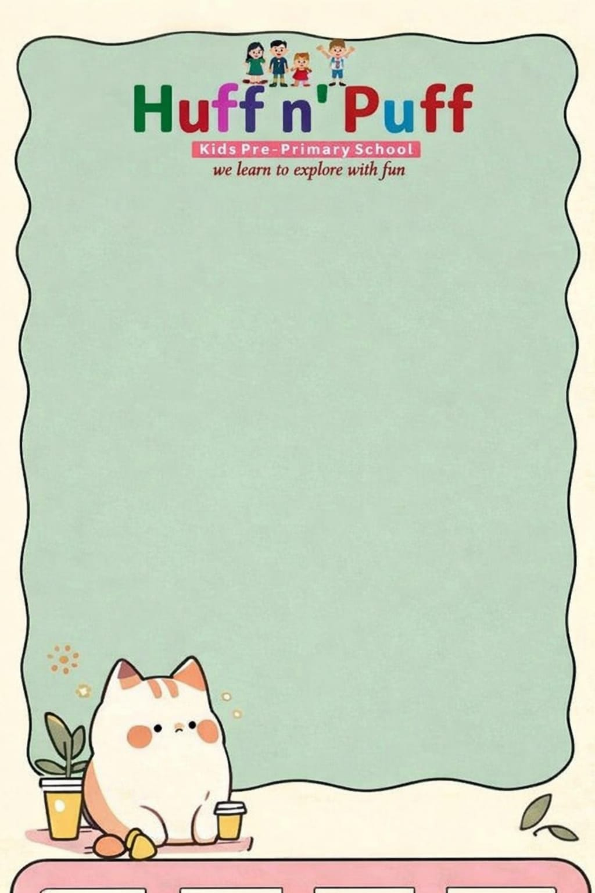
Class-5 Syllabus(Session 2026-2027)
April
हिंदी पाठयपुतक- उठो धरा के अमर सपूतों ।
हिंदी व्याकरण- भाषा,लिपि और व्याकरण, वर्ण विचार
English Grammar- The Sentences, Kind of sentences, Noun and their kind.
English Literature- How world got wisdom- If I know.
Maths- Large Numbers.
Computer- Evolution of computers.
E.v.s- Community Life and Traditions.
G.k- Extinct Animals, The Amazing Life Cycle of a Butterflie, Dinosaurs:-Giants of the Past
Our National Emblem.
Moral Values- Small Actions Big Changes.
Drawing- Page No 3,4,5,6.
May हिंदी पाठयपुतक- चांद की सेर, शहीद बिस्मिल ।
हिंदी व्याकरण- शब्द विचार, संज्ञा।
English Language- Noun and Gender, Noun (Singular and Plural),Countable and Uncountable Noun.
English Literature-King Dushyanta and Shakutala.
Maths- The Four Operations.
Computer- Advanced Features of Word.
E.v.s- Occupations and their Roles in Our Community.
G.k- Extinct Animals, The Amazing Life Cycle of a Butterflie, Dinosaurs:-Giants of the Past
Our National Emblem.
Moral Values- Small Actions Big Changes.
Drawing- Page No 3 4 5 6.

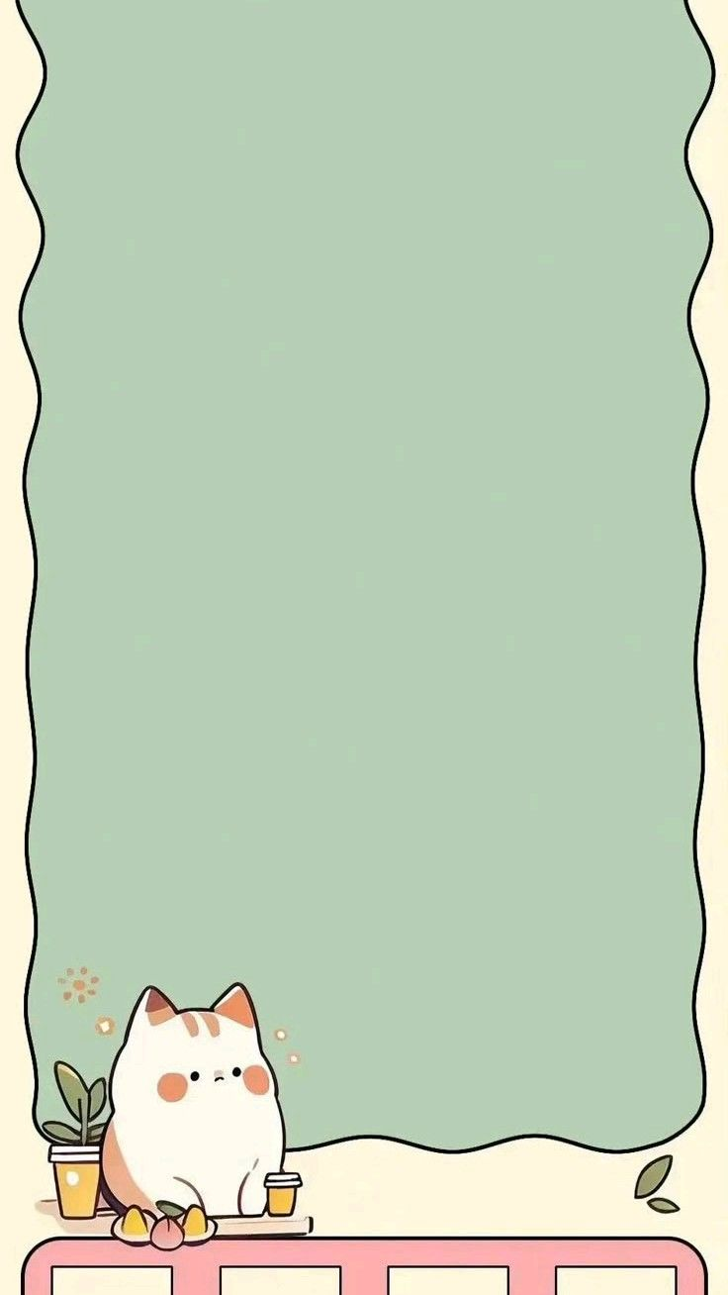
G.k- Awards and Honours, National Parks and Wildlife Sanctuaries.
Moral Values- The Creators Masterpiece.
Drawing- Page No 7,8,9,10.
June
Summer Vaccations
20th May to 20th June
July
हिंदी पाठयपुतक- उत्सव बेला, तेनाली रामन ।
हिंदी व्याकरण- संज्ञा के विचार: लिंग, वचन, कारक ।
English Language-Pronoun and its kinds, Verb, Adjective.
English Literature-The Boon of Boons, A Little Brave Boy.
Maths- Factors and Multiples, Fractions.
Computer- Working in Power Points 2021.
E.v.s- Mapping of Neighbourhood, Our Culture and Heritage.
G.k- India's Contribution to the world, Ranks in Indian Armed Forces,
Natural Wonders of The world, Voyagers of Discovery, Currency Around the World, Folk Theatre in India.
Moral Values- The Brave Engineer .
Drawing- Page No 11,12,13,14.
August
हिंदी पाठयपुतक- राम की भूमिका, सहजन के पेड़ ।
हिंदी व्याकरण- सवनाम, विशषण, क्रिया ।
English Language-Degrees of Adjective, Adverb,Prepositions
English Literature-Alice in Wonderland..
Maths- Decimals.

Computer- Introduction to Excel 2021
E.v.s-The Story of Time and Seasons, Life Cycle of Plants and Animals,.
G.k- Prithvi Theatre: A Legacy of Indian Theatre, Acting: Expressing through Performance, The Magic of Indian Movie Soundtrack, Famous Film Music Composers, Music in Movies, Careers in Dance,
Moral Values-The Worth of Hard Work.
Drawing- Page No 15,16,17,18.
September
'Its Exam Time'
(First Term Exam)
07th Sep 2026 to 19Sep 2026

October
हिंदी पाठयपुतक- कंप्यूटर, कदब के पेड़, समुद्री जीव व्हेल ।
हिंदी व्याकरण- काल, अविकारी शबद/अव्यय, विराम चिन्ह।
English Language-Conjunction ,Interjection,Articles
English Literature- The Story of Lazy Jack, Chhatrapati Shivaji.
Maths- Percentage,Time.
Computer- Editing in Excel 2021
E.v.s- Caring for Living Beings,.
G.k- Ganesh Acharya: The Dancing Star, Salsa: The Dance of Rhythm and Energy,
Journey to the Moon, The History of Cars, Responsible Use of Social Media, The Great
Inventions of 21st Century.
Moral Values-The Plastic Bag.
Drawing- Page No 19.20, 21,22.
November
हिंदी पाठयपुतक- कंप्यूटर, कदब के पेड़, समुद्री जीव व्हेल ।
हिंदी व्याकरण- काल, अविकारी शबद/अव्यय, विराम चिन्ह।
English Language-Conjunction ,Interjection,Articles
English Literature- The Story of Lazy Jack, Chhatrapati Shivaji.
Maths- Percentage,Time.
Computer- Editing in Excel 2021
E.v.s- Caring for Living Beings,.
G.k- Ganesh Acharya: The Dancing Star, Salsa: The Dance of Rhythm and Energy,
Journey to the Moon, The History of Cars, Responsible Use of Social Media, The Great
Inventions of 21st Century.
Moral Values-The Plastic Bag.
Drawing- Page No 19.20, 21,22.
December
हिंदी पाठयपुतक- कंप्यूटर, कदब के पेड़, समुद्री जीव व्हेल ।
हिंदी व्याकरण- काल, अविकारी शबद/अव्यय, विराम चिन्ह।
English Language-Conjunction ,Interjection,Articles
English Literature- The Story of Lazy Jack, Chhatrapati Shivaji.
Maths- Percentage,Time.
Computer- Editing in Excel 2021
E.v.s- Caring for Living Beings,.
G.k- Ganesh Acharya: The Dancing Star, Salsa: The Dance of Rhythm and Energy,
Journey to the Moon, The History of Cars, Responsible Use of Social Media, The Great
Inventions of 21st Century.
Moral Values-The Plastic Bag.
Drawing- Page No 19.20, 21,22.

January
Hindi: रज्जी, खेल शक्ति है पढ़।

Grammar: अनुच्छेद लेखन, डायरी लेखन, निबंध लेखन

Eng (G): Comprehension, Composition - Message / Notice Writing, Letter writing - Formal / Informal
(R): How the kangaroo got Her Pouch

Maths: Symmetry and Patterns, Data Handling

Computer: Programming in Scratch

E.V.S: Dealing with an Emergency

G.K: Save the Paper: Dried Fruits - Natures' Sweet Treats, The Family Puzzle, Directions, Mixed Reasoning

February
Moral values: Trust Your Feelings.

Drawing: Page no's 31, 32, 33, 34, 35

Eng (G): Paragraph Writing, Story Writing

Computer: Artificial Intelligence

Drawing: Page no. 36, 37, 38, 39, 40

March
'It's Exam Time'
(Final Term Exam)
01st March to 19 March 2027

